Lab 14-1 Creating an SDE Mapping to Extend the SRMW Using Siebel Data
Goals | To create a Source Dependent Extract (SDE) mapping that can be used to move data into the W_PERSON_DSX staging extension table in preparation for load into the W_PERSON_DX extension table in the Siebel Relationship Management Warehouse.
Scenario | You have identified the Siebel Relationship Management Warehouse extension table and column where you are going to store the cell phone number data. Now you must create mappings to coordinate the ETL process. The first step is to create a Source Dependent Extract mapping to extract data from the Siebel transactional database and load it into a staging extension table in the Siebel Relationship Management Warehouse.
Outcome | You will have a Source Dependent Extract mapping that will be used to extract the cell phone number data from the S_CONTACT table in the Siebel transactional database and load it into a corresponding column in the W_PERSON_DSX staging extension table in the Siebel Relationship Management Warehouse.
Time | 25 – 30 minutes
Environment | 
Instructions:
- If necessary, start the Informatica Designer tool and connect to the Siebel Informatica repository.
  - Select Start > Programs > Informatica PowerMart 6.2.2 OEM for Siebel > Designer.
  - Double-click SIEBEL_DW_REP.
  - In the Connect to Repository dialog box, enter the following:
Username: | Administrator
Password: | Administrator
  - Click Connect.
- Ensure that the source tables used by your SDE and SIL mappings are available in the Custom folder.
  - Select Custom > Sources > OLTP and confirm that S_CONTACT appears as a source.
  - Select Custom > Sources > OLAP and confirm that W_PERSON_DSX appears as a source.
- Ensure that the target tables used by your SDE and SIL mappings are available in the Custom folder.
  - Select Custom > Targets and confirm that W_PERSON_DSX and W_PERSON_DX both appear as targets.
- Set ROW_WID as the primary key for W_PERSON_DX. This is used to relate the W_PERSON_DX table to the W_PERSON_D table.
  - Select the Custom folder and select Tools > Warehouse Designer.
  - From Custom > Targets, drag and drop W_PERSON_DX into the Warehouse Designer window.
  - Double-click the W_PERSON_DX table.
  - In the Edit Tables dialog box, click the Columns tab.
  - Select ROW_WID and select Primary Key as the Key Type.
  - Click Apply.
  - Click OK.
- Change the length of the ATTRIB_01 column from 30 to 40 in the W_PERSON_DSX source for your SIL mapping to match the column length of CELL_PH_NUM in S_CONTACT in the Siebel transactional database.
  - Select the Custom folder and select Tools > Source Analyzer.
  - Select Custom > Sources > OLAP > W_PERSON_DSX and drag W_PERSON_DSX into the Source Analyzer window.
  - Double-click the W_PERSON_DSX table and select the Columns tab in the Edit Tables dialog box.
  - Select the ATTRIB01 column and change its Prec to 40.
  - Click Apply.
  - Click OK.
- Change the length of the ATTRIB_01 column from 30 to 40 in the W_PERSON_DSX SDE target and W_PERSON_DX SIL target to match the column length of CELL_PH_NUM in S_CONTACT in the Siebel transactional database. These changes need to be done in both in Informatica Designer and Microsoft SQL Server.
  - Apply the change in Informatica Designer.
    - Select the Custom folder and select Tools > Warehouse Designer.
    - Select Select Custom > Targets and drag W_PERSON_DSX and W_PERSON_DX into the Warehouse Designer window.
    - In each table (W_PERSON_DSX, W_PERSON_DX) in Warehouse Designer, change the ATTRIB01 column’s Prec to 40.
    - Select Repository > Save to save your changes.
  - Apply the change in Microsoft SQL Server.
    - Select Start > Programs > Microsoft SQL Server > Query Analyzer.
    - In the Connect to SQL Server dialog box, enter the following:
Login name | SIEBEL
Password | SIEBEL
    - Click OK.
    - In the Query window enter the following:
USE OLAP
ALTER TABLE W_PERSON_DSX
ALTER COLUMN ATTRIB_01 VARCHAR(40)
ALTER TABLE W_PERSON_DX
ALTER COLUMN ATTRIB_01 VARCHAR(40)
GO
    - Select Query > Execute.
    - Select File > Exit to close the SQL Query Analyzer.
- In Informatica Designer, create the Source Dependent Extract mapping (SDE_C_PersonDimensionExtension) using the CustomTemplateSDE_WaveDimension template provided in the Custom folder. SDE_C_ PersonDimensionExtension mapping extracts and moves the data from the source table S_CONTACT to the target table W_PERSON_DSX. The data does not undergo any major transformations in this mapping as it is moved from the source to the dimension staging extension table.
  - In the Custom folder, expand the Mappings sub-folder and drag and drop the CustomTemplateSDE_WaveDimension mapping up to its parent Mappings folder to make a copy of it.
  - Click Yes to copy the mapping.
  - In the Enter a New Mapping Name dialog box, type SDE_C_PersonDimensionExtension and click OK.
- Open the Mapping Designer to begin modifying the SDE_C_PersonDimensionExtension mapping.
  - Select Tools > Mapping Designer.
  - Drag and drop the SDE_C_PersonDimensionExtension mapping into the Mapping Designer window.
  - If prompted, click Yes to close the existing mapping.
- Add and modify the source definition for the SDE_C_PersonDimensionExtension mapping. You are building a mapping to extract source data from the S_CONTACT table.
  - Click S_DD_CAMP_WAVE Source Definition and delete it.
  - Click Yes.
  - From the OLTP source, drag and drop the S_CONTACT source into the Mapping Designer. By default, a Source Qualifier transformation is created.
  - Select the new Source Qualifier transformation and delete it.
  - Click Yes.
- Rename, link, and modify the existing Source Qualifier transformation.
  - Double-click SQ_S_DD_CAMP_WAVE Source Qualifier.
  - In the Transformation tab of the Edit Transformations dialog box, click Rename.
  - In the Rename Transformation dialog box, type SQ_S_CONTACT and click OK.
  - Click Apply.
  - Click OK.
  - Drag and drop the ROW_ID column from S_CONTACT Source Definition to its corresponding column in SQ_S_CONTACT Source Qualifier. A blue arrow appears indicating the connection.
  - Scroll through the S_CONTACT Source Definition to locate the CELL_PH_NUM column.
  - Drag and drop CELL_PH_NUM from S_CONTACT Source Definition to an empty column on SQ_S_CONTACT Source Qualifier.
  - Delete the old port from SQ_S_CONTACT Source Qualifier.
    - Double-click SQ_S_CONTACT Source Qualifier.
    - Click the Ports tab of the Edit Transformations dialog box and select the DT_LAG_UNITS_CD port.
    - Click the Delete button to delete the port. Do not close the dialog box.
- Modify the SQ_S_CONTACT Source Qualifier by deleting unnecessary ports and editing SQL to reference correct view and columns.
  - In the Edit Transformations dialog box, click the Properties tab.
  - For the SQL Query transformation attribute, click the down arrow button in the Value field to open the SQL Editor. Edit the SQL to appear as follows. Examine the SQL carefully. It retrieves data from the change capture view (V_CONTACT). The change capture view is based on the S_CONTACT table in the transactional database. The $$Hint1 is a parameter variable that can be optionally used to improve the performance of SQL query. You are not using this is in the training.
SELECT $$Hint1
S_CONTACT.ROW_ID,
S_CONTACT.CELL_PH_NUM
FROM
V_CONTACT S_CONTACT
  - Click OK to close the SQL Editor.
  - Click Apply.
  - Click OK.
- Link and modify the EXPTRANS Expression. An Expression transformation is used to calculate values in a single row before writing to the target. In this step, you calculate the value of DATASOURCE_NUM_ID using a lookup procedure.
  - Drag and drop CELL_PH_NUM from SQ_S_CONTACT Source Qualifier onto an empty column on EXPTRANS Expression.
  - Delete the old port from EXPTRANS Expression.
    - Double-click EXPTRANS Expression.
    - Click the Ports tab of the Edit Transformations dialog box.
    - Select the DT_LAG_UNITS_CD port.
    - Click the Delete button to delete the port. Do not delete any other ports.
  - Change the ROW_ID Port Name to INTEGRATION_ID.
  - Click Apply.
  - Click OK.
- Add and link the target definition. W_PERSON_DSX is the target table for the data extracted from the source table (S_CONTACT).
  - Click W_WAVE_DSX Target Definition and delete it.
  - Click Yes to confirm the deletion.
  - In the Navigator, select Custom > Targets and drag and drop W_PERSON_DSX into the Mapping Designer window to create W_PERSON_DSX Target Definition.
  - Drag and drop INTEGRATION_ID and DATASOURCE_NUM_ID from EXPTRANS Expression onto their corresponding columns in W_PERSON_DSX Target Definition.
  - Drag and drop CELL_PH_NUM from EXPTRANS Expression to the ATTRIB01 column on W_PERSON_DSX Target Definition.
- Validate your work and update the repository:
  - If necessary, select View > Output to view the Output window.
  - Click the Validate tab of the Output window and select Mappings > Validate to verify that there are no inconsistencies in the new mapping. You should get a message similar to the following:
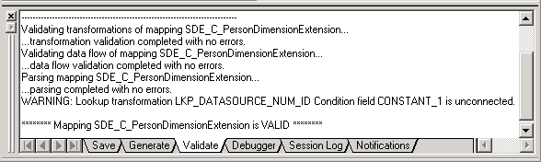
  - The flow of your mapping from source to target appears as follows.
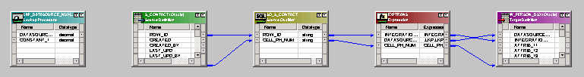
  - If your mapping is valid, select Repository > Save to update the repository.
Lab 14-2 Creating an SIL Mapping to Extend the SRMW Using Siebel Data
Goals | To create a Source Independent Load (SIL) mapping that can be used to move data into the W_PERSON_DX extension table from the W_PERSON_DSX staging table.
Scenario | You have built the SDE mapping necessary to stage the data for load into the Siebel Relationship Management Warehouse. You now must create the SIL load mapping used to load the data into its ultimate destination.
Outcome | You will have a source independent load mapping that extracts the data from the W_PERSON_DSX staging extension table and loads it into a corresponding column in W_PERSON_DX extension table in the Siebel Relationship Management Warehouse.
Time | 20 – 25 minutes
Instructions:
- If necessary, start the Informatica Designer tool and connect to the Siebel Informatica Repository.
  - Select Start > Programs > Informatica PowerMart 6.2.2 OEM for Siebel > Designer.
  - Double-click SIEBEL_DW_REP.
  - In the Connect to Repository dialog box, enter the following:
Username: | Administrator
Password: | Administrator
  - Click Connect.
- Create the Source Independent Load mapping SIL_C_PersonDimensionExtension using the CustomTemplateSIL_WaveDimension template provided in the Custom folder. SIL_C_PersonDimensionExtension mapping is used to extract, transform, and move the data from the dimension staging extension table (W_PERSON_DSX) to the target dimension extension table (W_PERSON_DX). The data undergo significant changes in this mapping as they are moved from the dimension staging extension to the target table.
  - In the Custom folder, expand the Mappings folder and drag and drop the CustomTemplateSIL_WaveDimension mapping up to its parent Mappings folder to make a copy of it.
  - Click Yes to confirm the copy.
  - In the Enter a New Mapping Name dialog box, type SIL_C_PersonDimensionExtension.
  - Click OK.
- Open the Mapping Designer to begin modifying the SIL_C_PersonDimensionExtension mapping.
  - Select Tools > Mapping Designer.
  - Drag and drop the SIL_C_PersonDimensionExtension mapping into the Mapping Designer window.
  - If prompted, click Yes to close the existing mapping.
- Add the source definition and link to the existing source qualifier. This new Source Definition represents the source table object (W_PERSON_DSX) in this mapping.
  - Select W_WAVE_DSX Source Definition and delete it.
  - Click Yes to confirm the delete.
  - In the Navigator, select Custom > Sources > OLAP.
  - Drag and drop the W_PERSON_DSX source into the Mapping Designer window. By default, a Source Qualifier transformation is created.
  - Select the new Source Qualifier transformation and delete it.
  - Click Yes to confirm the deletion.
  - Drag and drop INTEGRATION_ID, DATASOURCE_NUM_ID, and ATTRIB_01 from W_PERSON_DSX Source Definition to their corresponding columns on SQ_W_WAVE_DSX Source Qualifier.
- Rename and link the SQ_W_WAVE_DSX Source Qualifier transformation. This modified Source Qualifier transformation represents the row set retrieved from source objects before undergoing subsequent transformations.
  - Double-click SQ_W_WAVE_DSX Source Qualifier.
  - In the Transformation tab of the Edit Transformations dialog box, click Rename.
  - In the Rename Transformation dialog box, type SQ_W_PERSON_DSX.
  - Click OK.
  - In the Ports tab, change the ATTRIB01 port’s Prec to 40.
  - Click Apply.
  - Click OK.
- Rename the LKP_W_WAVE_D Lookup Procedure and modify it to point to the correct lookup table. This transformation queries the target table (W_PERSON_D) to determine which rows have the same INTEGRATION_ID and DATASOURCE_NUM_ID. These rows will be updated, while the rest of the rows in the staging table will be inserted in the target table (W_PERSON_DX).
  - Double-click LKP_W_WAVE_D Lookup Procedure.
  - In the Transformation tab of the Edit Transformations dialog box, click Rename.
  - In the Rename Transformation dialog box, type LKP_W_PERSON_D.
  - Click OK.
  - Click the Properties tab.
  - For the Lookup table name transformation attribute, change the value to W_PERSON_D.
  - For the Lookup SQL Override transformation attribute, click the down arrow button in the Value field to open the SQL Editor and edit the SQL to query the correct tables. This lookup SQL override ensures that only records from the extension table (W_PERSON_DSX) for which there are corresponding records in the main table (W_PERSON_D) are extracted.
    - Edit the SQL to appear as follows (The W_WAVE_D table is replaced with W_PERSON_D table and W_WAVE_DSX table is replaced with W_PERSON_DSX table).
SELECT
W_PERSON_D.ROW_WID as ROW_WID,
W_PERSON_D.INTEGRATION_ID as INTEGRATION_ID,
W_PERSON_D.DATASOURCE_NUM_ID as DATASOURCE_NUM_ID
FROM
W_PERSON_D,
W_PERSON_DSX
WHERE
W_PERSON_D.INTEGRATION_ID = W_PERSON_DSX.INTEGRATION_ID AND
W_PERSON_D.DATASOURCE_NUM_ID =
W_PERSON_DSX.DATASOURCE_NUM_ID
    - Click OK to close the SQL Editor.
  - Click Apply.
  - Click OK.
- Rename LKP_W_WAVE_DX Lookup Procedure and modify it to point to the correct lookup table. Given the record’s unique identifier (ROW_WID) of the base table (W_PERSON_D), this lookup retrieves the corresponding record’s ROW_WID from the extension table (W_PERSON_DSX).
  - Double-click LKP_W_WAVE_DX Lookup Procedure.
  - In the Transformation tab of the Edit Transformations dialog box, click Rename.
  - In the Rename Transformation dialog box, type LKP_W_PERSON_DX.
  - Click OK.
  - Click the Ports tab.
  - Select the ETL_PROC_WID port and click the Delete button to delete it.
  - Click the Properties tab.
  - For the Lookup table name transformation attribute, change the value to W_PERSON_DX.
  - Click Apply.
  - Click OK.
- Modify ports and create links for EXPTRANS Expression. Expression transformation allows calculations to be performed to rows. In this case, it is used to accomplish the following: 1) to create a flag to identify whether a row is a new or existing row and 2) to calculate the ETL_PROC_WID value.
  - Link the ATTRIB_01 from SQ_W_PERSON_DSX Source Qualifier to the ATTRIB_01 port on the EXPTRANS Expression.
  - Once you have verified the connection, double-click the EXPTRANS Expression transformation.
  - Click the Ports tab.
  - In the Ports tab of the Edit Transformations dialog box, change the ATTRIB01 port’s Prec
to 40.
  - Rename the WAVE_D_ROW_WID port to PERSON_D_ROW_WID.
  - Rename the WAVE_DX_ROW_WID port to PERSON_DX_ROW_WID.
  - For the INSERT_UPDATE_FLG port, click the down arrow button in the Expression field to open the Expression Editor.
  - Edit the formula so that it appears as follows:
IIF(ISNULL(PERSON_DX_ROW_WID),'INSERT','UPDATE')
  - Click Validate.
  - Click OK to confirm that the expression parsed successfully.
  - Click OK to return to the Edit Transformation dialog box.
  - Click Apply.
  - Click OK.
  - Drag and drop ROW_WID from LKP_W_PERSON_D Lookup Procedure to PERSON_D_ROW_WID in EXPTRANS Expression.
  - Drag and drop ROW_WID from LKP_W_PERSON_DX Lookup Procedure to PERSON_DX_ROW_WID in EXPTRANS Expression.
- Verify your work. Your mapping should appear in the Mapping Designer as follows:
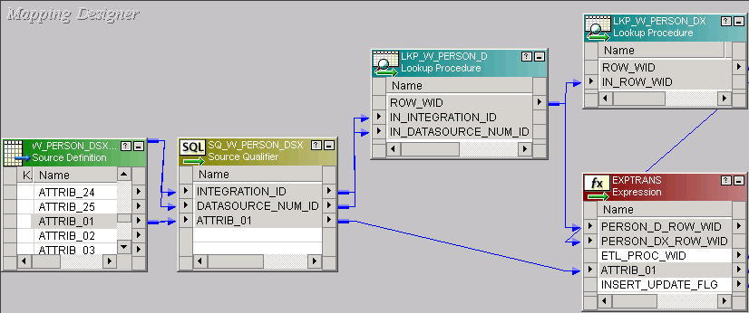
- Modify ports, edit filter conditions, and add links for the FILTRANS Filter transformation. This filter transformation filters out rows that are not there in the main dimension table (W_PERSON_D).
  - Verify that the ATTRIB_01 port from EXPTRANS Expression transformation is connected to the ATTRIB_01 port on the FILTRANS Filter transformation.
  - Once you have verified the connection, double-click FILTRANS Filter.
  - Click the Ports tab.
  - In the Ports tab of the Edit Transformations dialog box, change the ATTRIB01 port’s
Prec to 40.
  - Rename the WAVE_D_ROW_WID port to PERSON_D_ROW_WID.
  - Select the LKP_ETL_PROC_WID port and click the Delete button to delete it.
  - Click the Properties tab.
  - For the Filter Condition transformation attribute, click the down-arrow button in the Value field to open the Expression Editor.
  - Edit the expression so that it appears as follows:
NOT ISNULL(PERSON_D_ROW_WID)
  - Click Validate.
  - Click OK to confirm the expression parsed successfully.
  - Click OK to close the Expression Editor.
  - Click Apply.
  - Click OK.
  - Ensure PERSON_D_ROW_WID port in EXPTRANS Expression transformation is linked to PERSON_D_ROW_WID in FILTRANS Filter transformation.
- Link the UPDTRANS Update Strategy. This reusable Update Strategy transformation is used to handle the update strategy for rows for insert and updates.
  - Verify that ATTRIB_01 from FILTRANS Expression transformation is connected to the ATTRIB_01 port on the UPDTRANS Update Strategy.
  - Double-click the UPDTRANS Update Strategy.
  - In the Ports tab of the Edit Transformations dialog box, change the ATTRIB01 port’s Prec to 40.
  - Click the Properties tab.
  - For the Update Strategy Expression transformation attribute, click the down arrow button in Value field to open the Expression Editor.
  - Enter the following formula. The Update Strategy transformation uses this logic to decide whether a given record should be inserted or updated based on the value of INSERT_UPDATE_FLAG port set in the previous step.
IIF((INSERT_UPDATE_FLG = 'INSERT'),DD_INSERT,DD_UPDATE)
  - Click Validate to validate the Update Strategy Expression:
  - Click OK to confirm that the expression parsed successfully.
  - Click OK to close the Expression Editor.
  - Click Apply.
  - Click OK.
- Verify your work. The flow from the EXPTRANS Expression to the UPDTRANS Update Strategy in your mapping should appear in the Mapping Designer as follows:
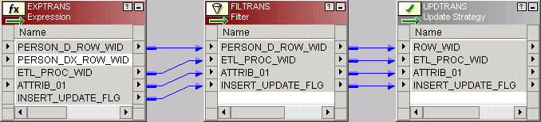
- Add and link the target definition. You are including the target dimension table (W_PERSON_DX) to this mapping.
  - Delete W_WAVE_DX Target Definition.
  - Click Yes to confirm the deletion.
  - In the Navigator, select Custom > Targets and drag and drop W_PERSON_DX into the Mapping Designer window.
  - Drag and drop ROW_WID, ETL_PROC_WID, and ATTRIB_01 from UPDTRANS Update Strategy to their corresponding columns on W_PERSON_DX Target Definition.
- Verify your work. The flow from the UPDTRANS Update Strategy to the W_PERSON_DX Target Definition in your mapping should appear in the Mapping Designer as follows:
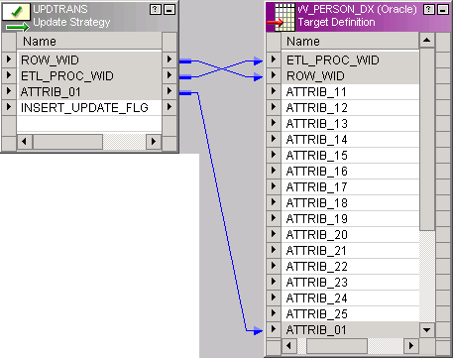
- Validate your work and update the repository.
  - If necessary, select View > Output to view the Output window.
  - Click the Validate tab of the Output window and select Mappings > Validate to verify that there are no inconsistencies in the new mapping. You should get a message similar to the following:
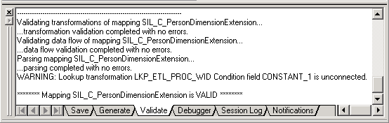
  - The flow of your mapping from source to target appears as follows.
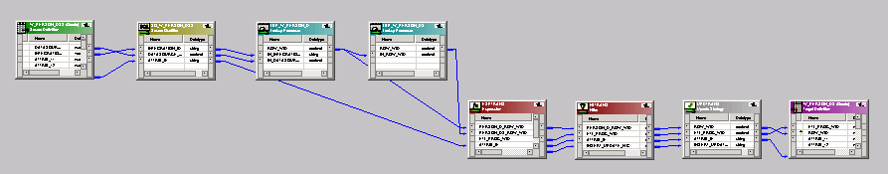
  - If your mapping is valid, select Repository > Save to update the repository.
Lab 14-3 Adding Sessions and Workflows
Goals | To create workflows that use the mappings created in previous labs to propagate the new data from the Siebel transactional database to the Siebel Relationship Management Warehouse.
Scenario | You have built the SDE and SIL mappings to perform the ETL processes necessary to propagate the cell phone number data from the Siebel transactional database to the Siebel Relationship Management Warehouse for analysis. Now you must create sessions and workflows in Informatica Workflow Manager that can be used to run the mappings.
Outcome | You will have sessions and workflows associated with the SDE and SIL mappings.
Time | 15 – 20 minutes
Instructions:
- If necessary, start Informatica Workflow Manager and connect to the Siebel Informatica repository:
  - Select Start > Programs > Informatica PowerMart 6.2.2 OEM for Siebel > Workflow Manager.
  - Double-click Siebel_DW_Rep.
  - In the Connect to Repository dialog box, enter the following:
Username: | Administrator
Password: | Administrator
  - Click Connect.
- Edit the MSSQL_OLAP data source connection to point to the OLAP database. In an earlier lab, you edited the MSSQL_OLAP data source connection to point to the OLAP_REV database.
  - Select SIEBEL_DW_SERVER.
  - Select Connections > Relational.
  - In the Relational Connection Browser, select the MSSQL_OLAP connection and click Edit.
  - Enter the following value:
Database name | OLAP
  - Click OK.
  - Click Close.
- Create a new workflow and session in the Custom folder for the Source Dependent Extract mapping you created.
  - Double-click Custom to expand the folder.
  - Select Tools > Workflow Designer.
  - Select Workflows > Create.
  - If prompted, click Yes to close the existing workflow.
  - In the Create Workflow dialog box, type the name SDE_C_PersonDimensionExtension.
  - Click OK.
  - Select Tasks > Create to add a session to the workflow.
  - In the Create Task dialog box, select Session type task, type the name SDE_C_PersonDimensionExtension , and click Create.
  - In the Mappings dialog box, select the SDE_C_PersonDimensionExtension mapping you built and click OK.
  - Click Done.
  - In the Workflow Designer window, drag the session off the Start task so that both tasks are visible.
  - Click the Link Tasks button , then click the Start task and drag the link to the SDE_C_PersonDimensionExtension session.
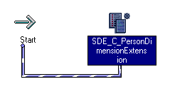
  - Edit the session properties. The Source connection is set to MSSQL_OLTP and Target connection is set to MSSQL_OLAP.
    - Double-click the SDE_C_PersonDimensionExtension session.
    - Click the Properties tab of the Edit Tasks dialog box.
    - In the $Source connection value attribute, click the down arrow button to open the Connection Browser.
    - In the Connection Browser, select MSSQL_OLTP and click OK. This is the location for the source table S_CONTACT.
    - In the $Target connection value attribute, click the down arrow button to open the Connection Browser.
    - In the Connection Browser, select MSSQL_OLAP and click OK. This is the location for the target table W_PERSON_DSX.
    - Click the Config Object tab of the Edit Tasks dialog box.
    - Click the lower Error Handling tab.
    - Verify that the Stop on errors attribute is set to a value of 0.
    - Click the Sources tab of the Edit Tasks dialog box.
    - Select the SQ_S_CONTACT instance and click the down-arrow button to edit its source connection.
    - In the Relational Connection Browser, select MSSQL_OLTP and click OK.
    - Click the Targets tab of the Edit Tasks dialog box.
    - Select the W_PERSON_DSX instance and click the down-arrow button to edit its target connection.
    - In the Relational Connection Browser, select MSSQL_OLAP and click OK.
    - Click the lower Properties tab in the Targets tab.
    - Change the Target load type attribute from Bulk to Normal. For large ETL loads, it is desirable to set the target load type to Bulk for SDE workflows but Normal target load type is fine for the purposes of this lab.
    - Select Truncate target table option.
    - Click Apply.
    - Click OK.
  - Select Repository > Save.
  - Verify that the SDE_C_PersonDimensionExtension workflow is valid in the output window.
- Create a new workflow and session in the Custom folder for the Source Independent Load mapping you created.
  - Select Workflows > Create.
  - If prompted, click Yes to close the existing workflow.
  - In the Create Workflow dialog box, type the name SIL_C_PersonDimensionExtension .
  - Click OK.
  - Select Tasks > Create to add a session to the workflow.
  - In the Create Task dialog box, select Session type task, type the name SIL_C_PersonDimensionExtension, and click Create.
  - In the Mappings dialog box, select the SIL_C_PersonDimensionExtension mapping and click OK.
  - Click Done.
  - In the Workflow Designer window, drag the session off the Start task so that both tasks are visible.
  - Click the Link Tasks button , then click the Start task and drag the link to the SIL_C_PersonDimensionExtension session.
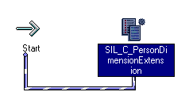
  - Edit the session properties. Both the Source and Target connections are set to MSSQL_OLAP database.
    - Double-click the SIL_C_PersonDimensionExtension session.
    - Click the Properties tab of the Edit Tasks dialog box.
    - In the $Source connection value attribute, click the down arrow button to open the Connection Browser.
    - In the Connection Browser, select MSSQL_OLAP and click OK. This is the location for the source table W_PERSON_DSX.
    - In the $Target connection value attribute, click the down arrow button to open the Connection Browser.
    - In the Connection Browser, select MSSQL_OLAP and click OK. This is the location or the target table W_PERSON_DX.
    - Click the Config Object tab of the Edit Tasks dialog box.
    - Click the lower Error Handling tab.
    - Verify that the Stop on errors attribute is set to a value of 0.
    - Click the Sources tab of the Edit Tasks dialog box.
    - Select the SQ_W_PERSON_DSX instance and click the down arrow button to edit its source connection.
    - In the Relational Connection Browser, select MSSQL_OLAP and click OK.
    - Click the Targets tab of the Edit Tasks dialog box.
    - Select the W_PERSON_DX instance and click the down-arrow button to edit its target connection.
    - In the Relational Connection Browser, select MSSQL_OLAP and click OK.
    - Click the lower Properties tab in the Targets tab.
    - Change the Target load type attribute from Bulk to Normal. The Target load type should not be set to Bulk for workflows containing data-driven (Update Strategy transformation) sessions. Most SIL workflows contain data-driven sessions.
    - Click Apply.
    - Click OK.
  - Select Repository > Save.
  - Verify that the SIL_C_PersonDimensionExtension workflow is valid in the output window.
Lab 14-4 Adding DAC Tasks and Running Customized ETL
Goals | To create and prioritize tasks in the DAC to propagate the new data from the Siebel transactional database to the Siebel Relationship Management Warehouse.
Scenario | You have built the sessions and workflows in Informatica Workflow Manager to run the SDE and SIL mappings. Now you must create DAC tasks and add them to execution plans that can be used to run the ETL.
Outcome | You will have loaded the cell phone number data into the W_PERSON_DX extension table.
Time | 40 – 45 minutes
Instructions:
- Log in to the DAC client.
  - Select Start > Programs > Siebel Analytics > Siebel DAC > DAC Client.
  - In the Login dialog box, enter the following and click Login:
Table owner name | SIEBEL
Password | SIEBEL
- Change the OLAP database connection back from OLAP_REV to the OLAP database.
  - Click Setup to open the Design view.
  - Click the Database Connections Top Pane tab.
  - Select the OLAP database connection.
  - In the Edit tab in the bottom pane, type OLAP as the Database name and click Save.
- Explore the task that extracts data for the Person Dimension.
  - Click Design to open the Design view.
  - Click the Task Definitions Top Pane tab.
  - Click Query.
  - In the Name field of the top pane, type *Person Dimension*.
  - Click Go.
  - Which task do you think extracts data for the Person Dimension?
  - Select Extract for Person Dimension in the list.
  - Click the Source Tables tab in the bottom pane.
  - Does the Extract for Person Dimension task use the S_CONTACT source table?
  - Click the Target Tables tab.
  - What is the target table of the Extract for Person Dimension task?
  - Click the Depends on Tasks tab.
  - What tasks does the Extract for Person Dimension task depend on?
  - Click the Dependent Tasks tab.
  - What tasks depend on the Extract for Person Dimension task?
- Create a new task to run the custom Source Dependent Extract workflow you have created.
  - Click New in the Top Pane toolbar.
  - In the Edit tab of the bottom pane, enter the following. Since this task populates the staging table, the Truncate Always option should be selected to empty the tables during both full and incremental ETL loads.
Name | Extract for Person Dimension Extension
Folder Name | Custom
Source DB | OLTP
Target DB | OLAP
Task Phase | Extract Dimension
Execution Type | Informatica
Priority | 5
Truncate Always | Selected
Continue On Error | Selected
  - Click the Picklist icon in the Command for Incremental Load field.
  - Click Import Sessions command button.
  - In the Importing Informatica Sessions dialog box, select the OLAP data source and click OK.
  - Click OK.
  - In the Choose Command for Incremental Load window, select SDE_C_PersonDimensionExtension and click OK.
  - Click the Picklist icon in the Command for Full Load field.
  - In the Choose Command for Incremental Load window, select SDE_C_PersonDimensionExtension and click OK.
  - Click Save.
  - Click the Source Tables tab.
  - Click Edit to open the Choose Source Tables window.
  - Click the Query button in Choose Source Tables window, type S_CONTACT, and click Go.
  - Select S_CONTACT and click Add.
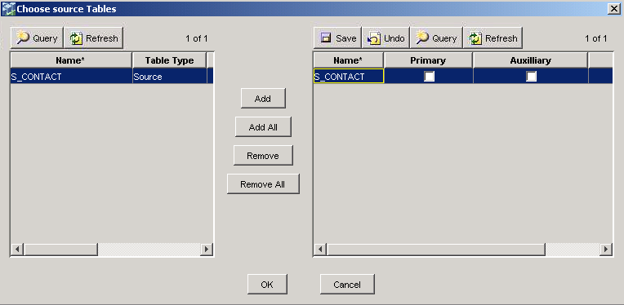
  - Query for and add the W_PARAM_G table, which is also sourced in the SDE_C_PersonDimensionExtension workflow.
  - Click OK.
  - Select Primary flag for the S_CONTACT source table.
  - Click Save.
  - Click the Target Tables tab.
  - Click Edit to open the Choose Target Tables window.
  - Click Query, type W_PERSON_D*, and click Go.
  - Select W_PERSON_DSX and click Add.
  - Click OK.
  - Select Primary flag for the W_PERSON_DSX target table.
  - Click Save.
- Set the dependencies for the Extract for Person Dimension Extension task. This task should depend on the same tasks to complete before running as the Extract for Person Dimension task, so that all processing is complete on the base table before it runs.
  - Click the Depends on Tasks tab.
  - Click Edit to open the Choose Tasks to depend on window.
  - Click Query, type *List Of Values*, and click Go.
  - Select Fix List of Values and Copy to OLTP and click Add.
  - Click Query, type *S_CONTACT*, and click Go.
  - Select Mark rows as changed for S_CONTACT because of changes in Auxiliary Tables and click Add.
  - Click OK.
  - Click Save.
- Explore the task that loads data into the Person Dimension.
  - Click Design to open the Design view.
  - Click the Task Definitions Top Pane tab.
  - Click Query.
  - In the Name field of the top pane, type *Person Dimension*.
  - Click Go.
  - Which task do you think loads data into the Person Dimension?
  - Select Load into Person Dimension in the list.
  - Click the Source Tables tab.
  - Does the Load into Person Dimension task use the W_PERSON_DS source table?
  - Click the Target Tables tab.
  - What is the target table of the Load into Person Dimension task?
  - Click the Depends on Tasks tab.
  - What tasks does the Load into Person Dimension task depend on?
  - Click the Dependent Tasks tab.
  - How many tasks depend on the Load into Person Dimension task?
- Create a new task to run the Source Independent Load workflow you have created.
  - Select the Load into Person Dimension task in the list.
  - Right-click the task and select Copy Record.
  - Select the Load into Person Dimension (2) task you created.
  - In the Edit tab of the bottom pane, enter or confirm the following. Since this task populates the main table, Truncate For Full Load should only be selected to ensure the table is emptied during the full ETL load but not during incremental ETL loads.
Name | Load into Person Dimension Extension
Folder Name | Custom
Command for Incremental Load | SIL_C_PersonDimensionExtension
Command for Full Load | SIL_C_PersonDimensionExtension
Source DB | OLAP
Target DB | OLAP
Task Phase | Load Dimension
Execution Type | Informatica
Priority | 5
Truncate For Full Load | Selected
  - Click Save.
  - Click the Source Tables tab.
  - Click Edit to open the Choose Source Tables window.
  - Click Remove All.
  - Query for and add the following source tables used in the SIL_PersonDimension workflow:
W_PARAM_G
W_PERSON_DSX
W_PERSON_D
W_PERSON_DX
  - Click OK.
  - Select Primary flag for the W_PERSON_DSX source table.
  - Click Save.
  - Click the Target Tables tab.
  - Click Edit to open the Choose Target Tables window.
  - Select W_PERSON_D in the right-hand list and click Remove.
  - Click Query, type W_PERSON_D* and click Go.
  - Select W_PERSON_DX and click Add.
  - Click OK.
  - Select Primary flag for the W_PERSON_DX target table.
  - Click Save.
- Set the dependencies for the Load into Person Dimension Extension task. This task depends on the Extract for Person Dimension Extension task because it needs the data to be present in the staging table. Also, it depends on the Load into Person Dimension task, because not only it is the base dimension table but also it does a lookup on the primary key for the Person Dimension table.
  - Click the Depends on Tasks tab.
  - Click Edit to open the Choose Tasks to depend on window.
  - Click Remove All.
  - Click Query, type *Person Dimension*, and click Go in the left-hand list.
  - Select Extract for Person Dimension Extension and click Add.
  - Select Load into Person Dimension and click Add.
  - Click OK.
  - Click Save.
- You want the Person Dimension Extension table loaded in the same ETL as the Person Fact and Person Dimension tables are loaded. Add the table to the PERSON FACT GROUP and preview to ensure that the sessions and tasks you’ve created will be run in the right order.
  - Click the Table Groups Top Pane tab while still in the Design view.
  - Query for PERSON FACT GROUP.
  - Click the Tables tab in the bottom pane.
  - Click Edit to open the Choose Tables dialog box.
  - Click Query, type W_PERSON_DX and click Go.
  - Select W_PERSON_DX and click Add.
  - Click OK.
  - In the top pane, click Preview.
  - Select all text in the Dependency window.
  - Select Start > Programs > Accessories > Notepad.
  - Paste the text into Notepad.
  - Verify that W_PERSON_DX table is added to the main table W_PERSON_F in PERSON FACT GROUP under the section Iteration:0.
  - Search for Task Name: Extract for Person Dimension Extension and scroll through its dependencies to verify that the dependencies you set above are being enforced.
  - Search for Task Name: Load into Person Dimension Extension and scroll through its dependencies to verify that the dependencies you set above are being enforced.
  - Close Notepad.
  - Click No to discard the results.
- Before running the ETL, query the W_PERSON_DX target table to confirm there is no data.
  - Select Start > Programs > Microsoft SQL Server > Query Analyzer.
  - In the Connect to SQL Server dialog box, type the following and click OK:
Login name | SIEBEL
Password | SIEBEL
  - In the Query window, enter the following:
USE OLAP
SELECT * FROM W_PERSON_DX
  - Select Query > Execute.
  - Verify that there is no data in W_PERSON_DX.
- In the Services dialog box, verify that the Informatica and Informatica Repository Server services are running.
- Edit the Sales Subject Area to enable only the PERSON FACT GROUP. In an earlier lab, you disabled all table groups except REVENUE FACT GROUP. This ensures that only tables in PERSON FACT GROUP under Sales Subject Area are extracted and populated when Sales execution plan is run. It is a best practice to prune table groups that are not required to be populated during the ETL load.
  - In DAC, click the Subject Areas tab in the top pane while in the Design view.
  - Select Sales Subject Area and click the Table Groups tab in the bottom pane.
  - Select Inactive for the REVENUE FACT GROUP.
  - Deselect Inactive for the PERSON FACT GROUP.
  - Click Save.
- Set the Refresh Date on the S_CONTACT table to January 1, 2000, 7 PM to ensure that you have a broad enough cross-section of data in the refresh.
  - Select Views > Setup > Database Connections.
  - Select the OLTP database connection.
  - Select the Tables lower pane tab.
  - Select the S_CONTACT table (Use Query function if necessary to locate this table).
  - Click Update.
  - Click OK in the Updating refresh dates dialog box.
  - Set the following in the Date dialog box:
Year | 2000
Month | January
Day | 1
Hour | 7 PM
Minute | 0
  - Click OK.
- Run the Sales execution plan.
  - Select Execute in the DAC toolbar.
  - In the Execution Plans tab, select Sales.
  - Click Run Now in the top pane.
  - In the Starting ETL dialog box, click Yes to confirm that you want to start the Sales execution plan.
  - Click OK to acknowledge that the request has been successfully submitted to the Informatica Server.
- Monitor the ETL plan execution using the options in the Execute view. When all tasks have completed, query to check the status of the tasks you just created. If necessary, use the Refresh buttons in the top and bottom panes to monitor the task execution status.
  - Select the Sales ETL you just ran in the Run History tab of the Execute view.
  - Click the Task Details bottom pane tab, and query for *Person Dimension Extension*. These tasks may take a while to complete. Click the Refresh buttons both in the Run History Top Pane and Task Details Bottom Pane.
  - Verify that the Extract for Person Dimension Extension and Load into Person Dimension Extension tasks have completed.
  - Scroll across the Load into Person Dimension Extension record and note the number of successful rows.
- Query the W_PERSON_DX table to verify that the cell phone number data has been loaded.
  - Select Start > Programs > Microsoft SQL Server > Query Analyzer.
  - In the Connect to SQL Server dialog box, enter the following:
Login name | SIEBEL
Password | SIEBEL
  - Click OK.
  - In the Query window enter the following:
USE OLAP
SELECT ATTRIB_01 FROM W_PERSON_DX
WHERE ATTRIB_01 IS NOT NULL
GO
  - Select Query > Execute.
  - Scroll through the column to verify that the cell phone numbers have been loaded.
Solutions 14-4 Adding DAC Tasks and Running Customized ETL
Answers:
3.f. Which task do you think extracts data for the Person Dimension?
Extract for Person Dimension
3.i. Does the Extract for Person Dimension task use the S_CONTACT source table?
Yes, it’s the primary source table.
3.k. What is the target table of the Extract for Person Dimension task?
W_PERSON_DS
3.m. What tasks does the Extract for Person Dimension task depend on?
It depends on Fix List of Values and Copy to OLTP, and Mark rows as changed for S_CONTACT because of changes in Auxiliary tables.
3.o. What tasks depend on the Extract for Person Dimension task?
Extract Rows to be mark as deleted in Person Dimension, Load SCD into Person Dimension, and Load into Person Dimension all depend on the Extract for Person Dimension task.
6.f. Which task do you think loads data into the Person Dimension?
Load into Person Dimension
6.i. Does the Load into Person Dimension task use the W_PERSON_DS source table?
Yes, it is the primary source table.
6.k. What is the target table of the Load into Person Dimension task?
W_PERSON_D
6.m. What tasks does the Load into Person Dimension task depend on?
It depends on Extract for Person Dimension, Load for List Of Values, Load into Geography Dimension, and Load into Household Dimension.
6.o. How many tasks depend on the Load into Person Dimension task?
28

